CV Format 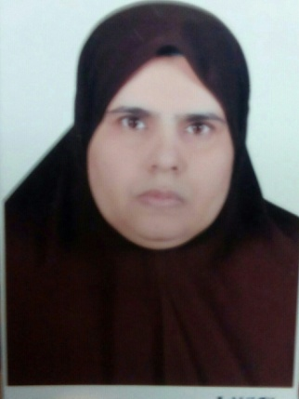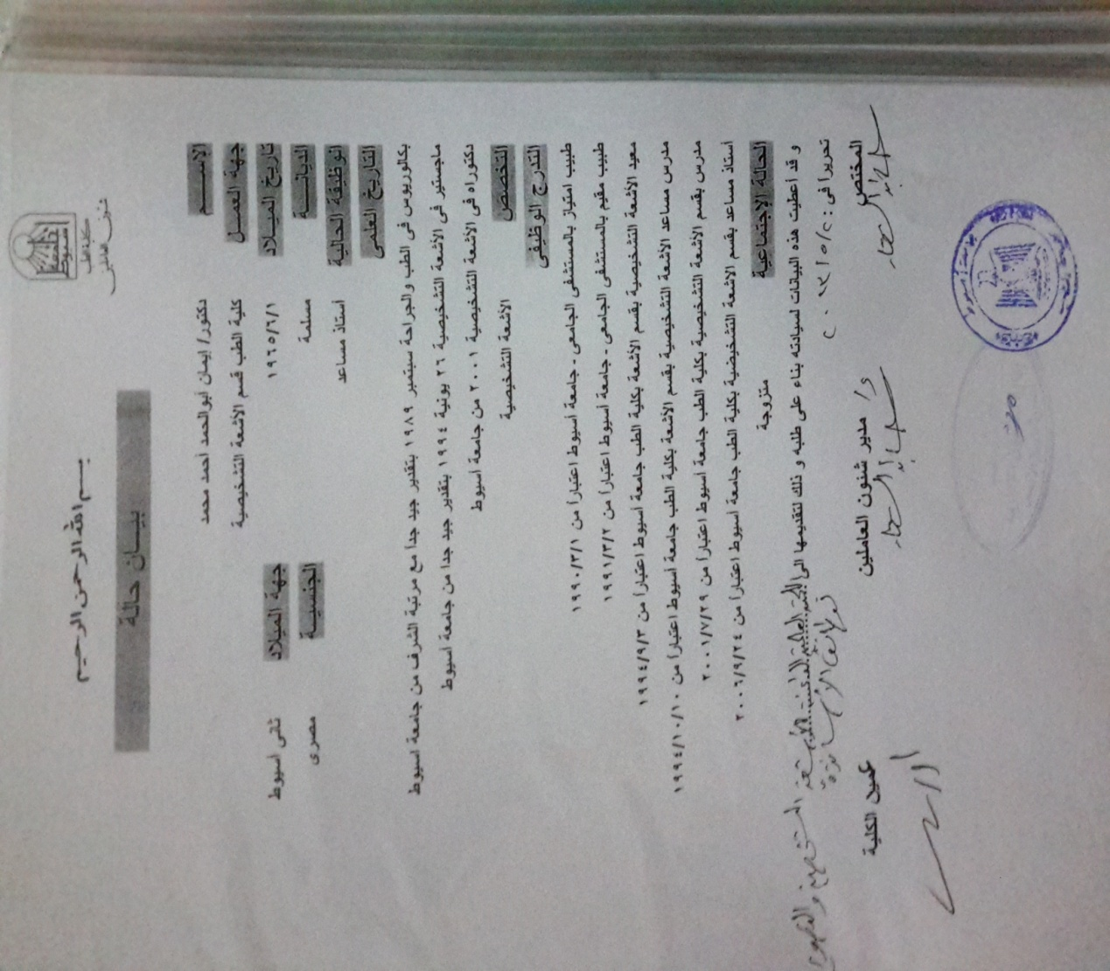
1. Basic Information
ايمان ابو الحمد احمد |  |  | Eman Abo Elhamd Ahmad
Date of Birth: 1-6-1965
National ID
Last University Degree  Prof.of Radiodiagnosis |  | Faculty of Medicine,Assiut University, Egypt |  | Graduation Date  MBB CH, 1989  MSc(Radiodiagnosis),1994  MD (Radiodiagnosis),2001  Assisstant prof.2006  Prof.of Radiodiagnosis,2013
Title: |  | Field of specialization:Carotid Doppler flow Imaging  Woman Imaging(breast sonography)
Affiliation:
Current Position:
Contact Information:
Mobile Phone: 01001980793 Fax: E-mail dr.eman_08@yahoo.com
Last three recent relevant publications
Authors (underline your name), year, title, Journal, vol. and pages
1 | Attendance and active participation of ESWIH Breast Imaging workshop on 16-17 December 2006 at New kasr El Einy Teaching Hospital  Certificate of attendance of : ESWIH Breast Imaging workshop on 12-14 June,2008  Attendance and active participation of ESWIH Breast Imaging workshop and conference:Breast Imaging Update2014 on 12-13 November,2014
2 | Supervising MSc:  Recent Advances in breast cancer imaging 26-1-2010 to 18-7-2011
3 | Current supervision ofMSc:  Value of MRI Perfusion in Descrimination between Benign and Malignant Breast Masses.
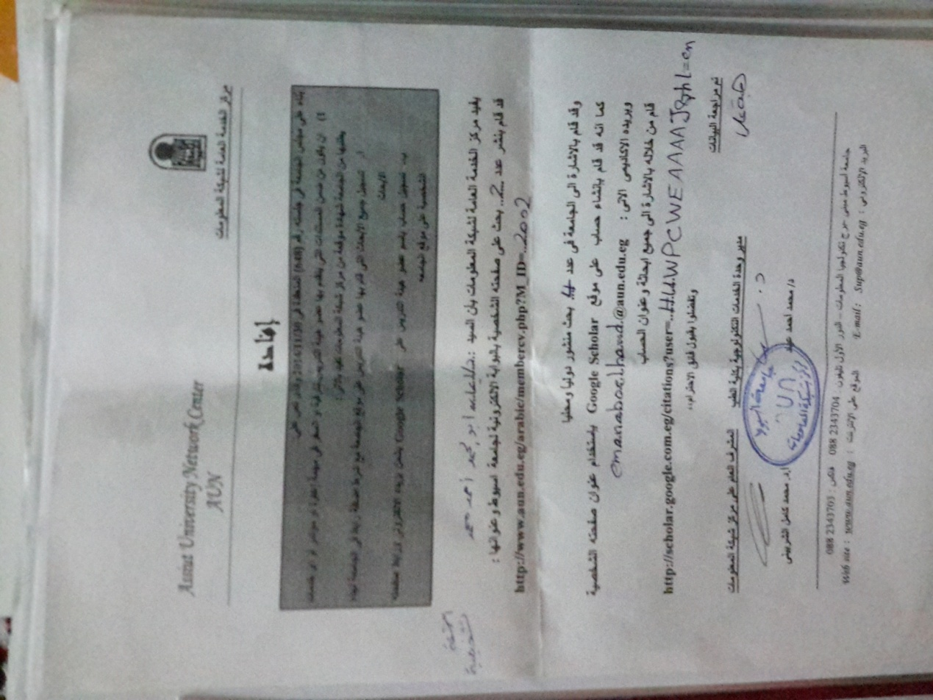

1-The value of lipoprotein(A), Homocysteine, and Doppler of Carotid and femoral arteries in assessment of Atherosclerosis in asymptomatic cardiovascular risk factors
2-Role of Magnetic resonance imaging in the evaluation of exophthalmos
3-Magnetic Resonance Imaging Findings of two sellar lesions:Pituitary adenoma and craniopharyngioma.
4-Role of Multidetector CT in diagnosis of acute pulmonary embolism
5-Assessment of Biocorrelates for brain involvement in female patients with Rheumatoid Arthritis
6-Multidetector Computed Tomography of Diaphragm:Anatomic variants and diagnostic problems in adult population.
7-Impact of intrauterine growth restriction on neonatal frontal lobe dimensions (Transcranial sonographic measurrments)
8-Multidetector Computed Tomography evaluation in neonatal respiratory distress:clinical implication

